|  |
| --- |
| Group 12 |
| Machine Learning |
| Teaching a Machine to Think like a Human |

|  |
| --- |
| Ahmet Akgun & Tim Prast  10-12-2021 |

Table of Contents

Introduction 2

Machine Learning 2

How does a Machine learn 3

Machine Learning in Our Daily Lives 5

Our Relationship with Machine Learning 6

References 7

## Introduction

Machine Learning is the way by which a machine can interpret, understand and make meaning from a large volume of data. It is often purported that they do this in a way that mimics human behaviour and methodology. “Machine learning is an umbrella term that refers to a broad range of algorithms that perform intelligent predictions based on a data set. These data sets are often large, perhaps consisting of millions of unique data points. Recent progress in machine learning has attained what appears to be a human level of semantic understanding and information extraction, and sometimes the ability to detect abstract patterns with greater accuracy than human experts” (J, et al., 2019). Machine learning and artificial intelligence are symbiotic, in the sense that one cannot exist without at least some aspect of the other. Therefore, to gain a true understanding of Machine Learning, it is important for us to understand what Artificial Intelligence is.

As defined by Prof Dalvinder Singh Grewal, PhD; “artificial intelligence is the mechanical simulation system of collecting knowledge and information and processing intelligence of universe: (collating and interpreting) and disseminating it to the eligible in the form of actionable intelligence.” (IOSR-JCE, 2021) It is the way by which a machine collects, collates, and acts on information it receives from artificial sensors. What makes it different from natural intelligence is that the processing is done entirely through artificial means and sensors. Artificial intelligence allows information to be collected by a machine’s software and hardware, usually a type of sensor, to be used by the machine to learn. This differs from machine learning, where its intent is to maximise the self-cognition of a machine with little to no human intervention. Unlike other types of artificial intelligence, machine learning does not require intensive programming and it allows a machine to learn by itself. This allows a machine to learn by itself.

## Machine Learning

The concept of machine learning falls into three differing categories, (IBM, 2021) supervised, unsupervised and semi-supervised. In supervised learning, a machine is given a dataset and instructed to interpret it using a defined logical sequence. In unsupervised learning, the dataset is interpreted by the machine using a sequence of its own creation. It does not rely on human intervention to discover hidden patterns or data groupings. Semi-supervised learning uses a combination of both. It provides the machine with a smaller dataset and a defined logical sequence, which allows the machine to learn and adapt to create its own rationale to apply to future datasets. This can be useful when a machine creator only has access to limited number of datasets; by exposing the machine to many smaller sets it can be taught more with less overall exposure. An automated system capable of self-learning can predict the result of a situation, an event or task based on the relevant information available. Using this logic, a machine can in essence pre-empt future outcomes, based on historical datasets.

The understanding and development of machine learning has diversified greatly over the past couple of years. Recent discoveries have branched into new areas of study such as: automated machine learning, neural Networks[1] and transfer learning, showcasing some of the most advanced machine learning technologies and applications.

Automated machine learning simplifies data selection, processing, and extraction. This method reduces the time and resources needed to achieve desired results. More notably, it enables people who do not possess the knowledge or skills in machine learning to apply this technology to their field of work.

Neural networks are designed to emulate structures similar to that of the brains of animals and humans. Organic brains have neurons (nerve cells) to process information that is received from the five major senses (sight, sound, taste etc.); whereas artificial neural networks are composed of nodes that compute information from non-biological sensors. Machine learning is based on a machines ability to learn from the data provided to it, but neural networks learn by classifying data after first processing it through their nodes, similar to the way in which a human brain operates.

Transfer learning is a method of machine learning that enables the data from a particular task to be carried to another related task. This method provides the opportunity for a machine to gain more knowledge and experience, thus making it more effective in future tasks. The machine will essentially learn from the repeated iterations of a given task.

## How does a Machine learn?

Data and algorithms are the two main components of machine learning technology. The sophistication of an algorithm will determine the path a machine will follow whilst training itself. The quality of the data the machine has access to will drastically affect the content created by a self-learning system. Consequently, implementing more mathematical and geometrical applications like statistics, probability and charting will increase the intelligence of learning machines. Developments in the discipline of data science will allow machines to be fed information that is of a higher quality and greater quantity. Therefore, training and employing more data analysts will help develop machines that are capable of sorting information faster and with a greater degree of accuracy.

A machine can be programmed to learn based on the data it is fed. If you need a machine to learn to recognise a street scene and to navigate using modern roadways, then it must be fed the required information. In this instance, the field of study of Computer Vision is applied. Computer vision can be broken down into three separate categories: semantic segmentation, image classification and object detection. Semantic segmentation can be understood as giving a machine the information to   
“understand the structures and components of an image on a pixel level. Methods for semantic segmentation try to make predictions about the structures and objects in an image.” (Marius, 2021)  
An example of which can be seen below.

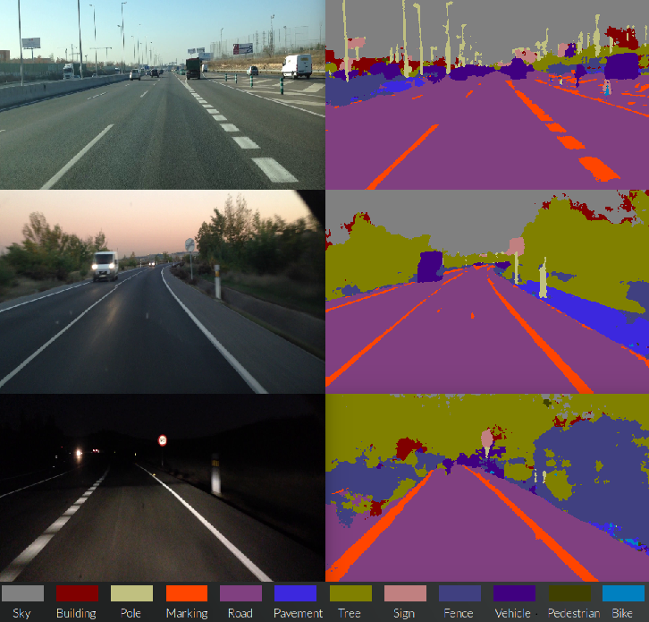

Figure 1 (Example cases of pixel wise segmentation performed by SegNet on real road scenarios, 2016) (Arroyo, 2016)

Unlike the example of semantic segmentation shown above, image classification focuses on the image holistically, rather than on its individual parts. It classifies the subject using the key component of an image. Tied directly to image classification is object detection. Object detection technology works to identify the “instances of objects of a certain class within an image.” (Marius, 2021). In this sense, image classification might be used to feed data of a certain data type to an object detection machine learning algorithm to help it develop.

See also this document’s section on Autonomous Vehicles for more information relating to the machine learning behind a vehicles’ autonomous future.

Natural language processing (NLP) is a field of machine learning that we explore in another section of this document, but is worth mentioning while we are exploring the idea of machine learning as a whole.

While natural language processing is a large field of study, “all of them (the different fields of study within NLP) try to deduct some meaning from our language and perform calculations based on our language and its components. Algorithms based on NLP can be found in various applications and industries. Just to name a few applications which you might encounter every day such as translators, social media monitoring, chatbots, spam filters, grammar check in Microsoft word or messengers and virtual assistants.” (Marius, 2021)

Deep learning is a sub-type of machine learning technology and over the recent years it has received substantial interest from industry leaders and innovators. It mainly benefits from image and audio processing, artificial neural networks and both supervised and unsupervised learning styles. Traditional learning machines would require an expert to set their definitions, whereas machines with deep structured learning can differentiate objects from another by analysing their appearance and voice. Consequently, they tend to follow similar learning patterns to humans' when processing raw data.

## Machine Learning in Our Daily Lives

Although at an early stage, deep learning technology is already used in digital vocabularies, translators, self-driving vehicles and video streaming platforms. Finance, electronic commerce, logistics and healthcare industries are widely benefitting from deep learning systems. When browsing shopping websites and viewing products, similar items displayed by the web browser use deep learning technology to find this information. Another example of this are the anti-fraud security systems of financial organisations that detect suspicious activities by analysing live transactions and comparing them with information with past transactions.

Machine learning will enhance an organisation’s data processing capabilities, thus increasing the productivity and profitability of a businesses. Marketing departments will have access to more specific information on the targeted demographics that would be interested in their products, providing them will more relevant statistics on markets and market behaviour. Production departments will have greater amounts of technical data available to them concerning the materials and techniques used to manufacture goods. Automated assembly lines will be assisted not only by human operators but learning machines that will enable power usage, material distribution and workflow optimisation. Logistics companies will have navigation systems augmented with learning machines, creating delivery routes with live traffic information, reducing delivery times and fuel consumption of their shipments. These examples showcase the value of machine learning in enabling us to efficiently and effectively utilise large datasets to achieve outcomes in a range of different industries.

The number of employment opportunities for people who are expects in the field of machine learning are sure to increase, as the technologies driving innovation develop and as it is use more by society.   
On the other side, the need for people who provide these services manually will likely decrease as automated systems reach maturity. Organisations adopting deep learning or machine learning technology more broadly will constantly be challenged with developmental obstacles. Such challenges would include the cost of maintenance and experimentation in real-life scenarios and finding fit-for-purpose datasets. Over time new methods and techniques will rise that will enhance machine learning in every aspect, making it more affordable and feasible for individuals and organisations to use.

## Our Relationship with Machine Learning

Today, virtual assistants and chatterbots already present on certain websites are powered by machine learning and natural language processing. When we enter questions into chat-boxes they can understand what the inquiry is about by detecting and processing keywords – this is after being fed and learning from large datasets of natural language libraries and human to human text-based interactions.   
This service saves both businesses and their customers a significant amount of time, by reducing the need for human-to-human interactions or waiting in virtual (or phone line) queues.

At this early stage, machine learning and natural language processing are not able to fully comprehend or grasp linguistic meanings in certain situations, but as develop they will become much more efficient assistants. Goods purchased from online-stores will reach homes quicker than ever before through machine learned route optimisation. Customers will also be provided more accurate delivery timelines and will be able track an items route in real-time.

When protective programs that defend our IT devices from malicious software are augmented with deep learning machines, they will provide an even greater line of defence. They will be empowered to do this by reacting in real-time more efficiently, drawing on thousands of different dataset scenarios. Machine taught anti-virus programs will be able to better identify and defend from threats as ill-intended hackers attempt to infiltrate a person’s IT system. By being one step ahead of attackers these programs will operate in both a proactive and protective manner.

Artificial intelligence, machine and deep learning are inter-related technologies. As one advances, the others benefit from the developments in that field. Advancements in these areas will make our digital and personal lives faster, safer and more affordable, as well as creating new fields for innovation in other areas of Information Technology.

References below are the ones cited in text – footnotes to be deleted

# References

Arroyo, R., 2016. *Research Gate.* [Online]   
Available at: https://www.researchgate.net/profile/Roberto-Arroyo-4/publication/304789242/figure/fig2/AS:380415174037504@1467709453041/Example-cases-of-pixel-wise-segmentation-performed-by-SegNet-on-real-road-scenarios.png  
[Accessed 12 October 2021].

IBM, 2021. *Ibm.com.* [Online]   
Available at: https://www.ibm.com/cloud/learn/machine-learning  
[Accessed 12 October 2021].

IBM, 2021. *Ibm.com.* [Online]   
Available at: https://www.ibm.com/au-en/cloud/learn/neural-networks  
[Accessed 12 October 2021].

IOSR-JCE, 2021. A Critical Conceptual Analysis of Definitions of Aritifical Intelligence as Applicable to Computer Engineering. *IOSR Journal of Computer Engineering,* 16(2), p. 13.

J, N., H, C. & M, B., 2019. Machine Learning: Applications of Artifical Intelligence to Imaging and Diagnosis. *Biophysical Reviews,* 11(1), pp. 111-118.

Marius, H., 2021. *Toward Data Science.* [Online]   
Available at: https://towardsdatascience.com/overview-state-of-the-art-machine-learning-algorithms-per-discipline-per-task-c1a16a66b8bb  
[Accessed 12 October 2021].

**DO NOT USE THE BELOW**

## References

Nichols, J., Herbert Chan, H. and Baker, M., 2019. Machine learning: applications of artificial intelligence to imaging and diagnosis. *Biophysical Reviews*, [online] 111-118(11). Available at: <https://www.ncbi.nlm.nih.gov/pmc/articles/PMC6381354/> [Accessed 12 October 2021].

*IOSR Journal of Computer Engineering (IOSR-JCE)*, 2021. A Critical Conceptual Analysis of Definitions of Artificial Intelligence as Applicable to Computer Engineering. 16(2), p.13.

Education, I., 2021. *What is Machine Learning?*. [online] Ibm.com. Available at: <https://www.ibm.com/cloud/learn/machine-learning> [Accessed 12 October 2021].

<https://www.researchgate.net/profile/Roberto-Arroyo-4/publication/304789242/figure/fig2/AS:380415174037504@1467709453041/Example-cases-of-pixel-wise-segmentation-performed-by-SegNet-on-real-road-scenarios.png> [Accessed 12 October 2021].

Ibm.com. 2021. *What are Neural Networks?*. [online] Available at: <https://www.ibm.com/au-en/cloud/learn/neural-networks> [Accessed 12 October 2021].

Medium. 2021. *Overview: State-of-the-Art Machine Learning Algorithms per Discipline & per Task*. [online] Available at: <https://towardsdatascience.com/overview-state-of-the-art-machine-learning-algorithms-per-discipline-per-task-c1a16a66b8bb> [Accessed 12 October 2021].

Medium. 2021. *Overview: State-of-the-Art Machine Learning Algorithms per Discipline & per Task*. [online] Available at: <https://towardsdatascience.com/overview-state-of-the-art-machine-learning-algorithms-per-discipline-per-task-c1a16a66b8bb> [Accessed 12 October 2021].

1.